|  |  |  |  |  |  |  |  |  |  |  |  |
| --- | --- | --- | --- | --- | --- | --- | --- | --- | --- | --- | --- |
| **Project Name: demo.opencart.com** | | | | | | | | | | | |
|  | | | | | | | | | | | |
| Bug ID | | 007 | | | | | Reporter | | | Kirill Brezhniev | |
| Test-case ID | |  | | | | | Position Reporter | | |  | |
| Description | | Wrong description in “MP3 Players” category | | | | | Submit Date | | | 20.11.20 | |
| URL | | https://demo.opencart.com/index.php?route=product/category&path=18_46 | | | | | Release Version | | | OPENCART.CMS 2.1.0.2 | |
| Priority | | medium | | | | | Environment | | | Opera 72.0.3815.320 | |
| Severity | | moderate | | | | | Assign to | | |  | |
|  | | | | | | | | | | | |
| Pre-conditions | | | Main page is opened | | | | | | | | |
| Dependencies | | |  | | | | | | | | |
| Steps to reproduce: | | | | | | | | | | | |
| N | Action | | | Inputs | Expected Output | Actual Output | | Screen  shots | Comments | |
| 1 | Hover a cursor over “MP3 Players” category | | |  | Correct number of laptops is displayed in subcategory | Number of products in subcategory is 0 | |  |  | |
| 2 | Click on the “Show All MP3” | | |  | Page with MP3 players opens displaying all MP3 | Page with MP3 players opens displaying all MP3 | |  |  | |
| 3 | Pay attention to the description of category | | |  | Description says about MP3 | Description says about laptops | | Bug7 |  | |

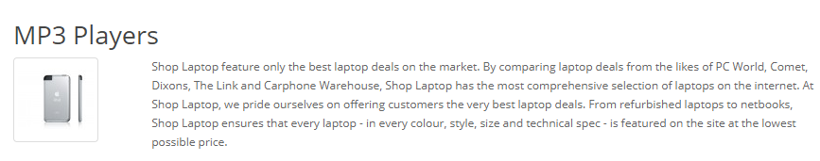bug 7